Rješenja za voditelja skupine:

**Instructions**

* Choose the color of the pawns and place the pawns on small circles of the same color.
* Before the start of the game, everyone should roll the dice once. The player with the highest number on the dice will start first.
* At the beginning you roll the dice **max** **3 times**. When you get the number 6, you place one your pawn in the first place in your color and solve the task.
* The other players take turns playing clockwise.
* In the continuation of the game, you move as many spaces as it says on the dice you rolled.
* If you get a 6 on the dice, you spin dice again.
* When you get to a certain field, you answer the question written on field.
* If you **don't know the answer**, you return to the position where you were before.
* If you give **the correct answer**, you stay on the new field and the next player plays.
* If one player enters the field where another player is already standing, he knocks down the other player's pawn and places it at the beginning place.
* The goal of the game is to first get all your pawns into the houses.
* Calculators are not allowed. The leader of game monitors whether your answers are correct.

Author: Viktorija Dimec Redecorated and translated: Martina Brkić

- od crvenog polja

- od plavog polja

- od narančastog polja

- od zelenog polja

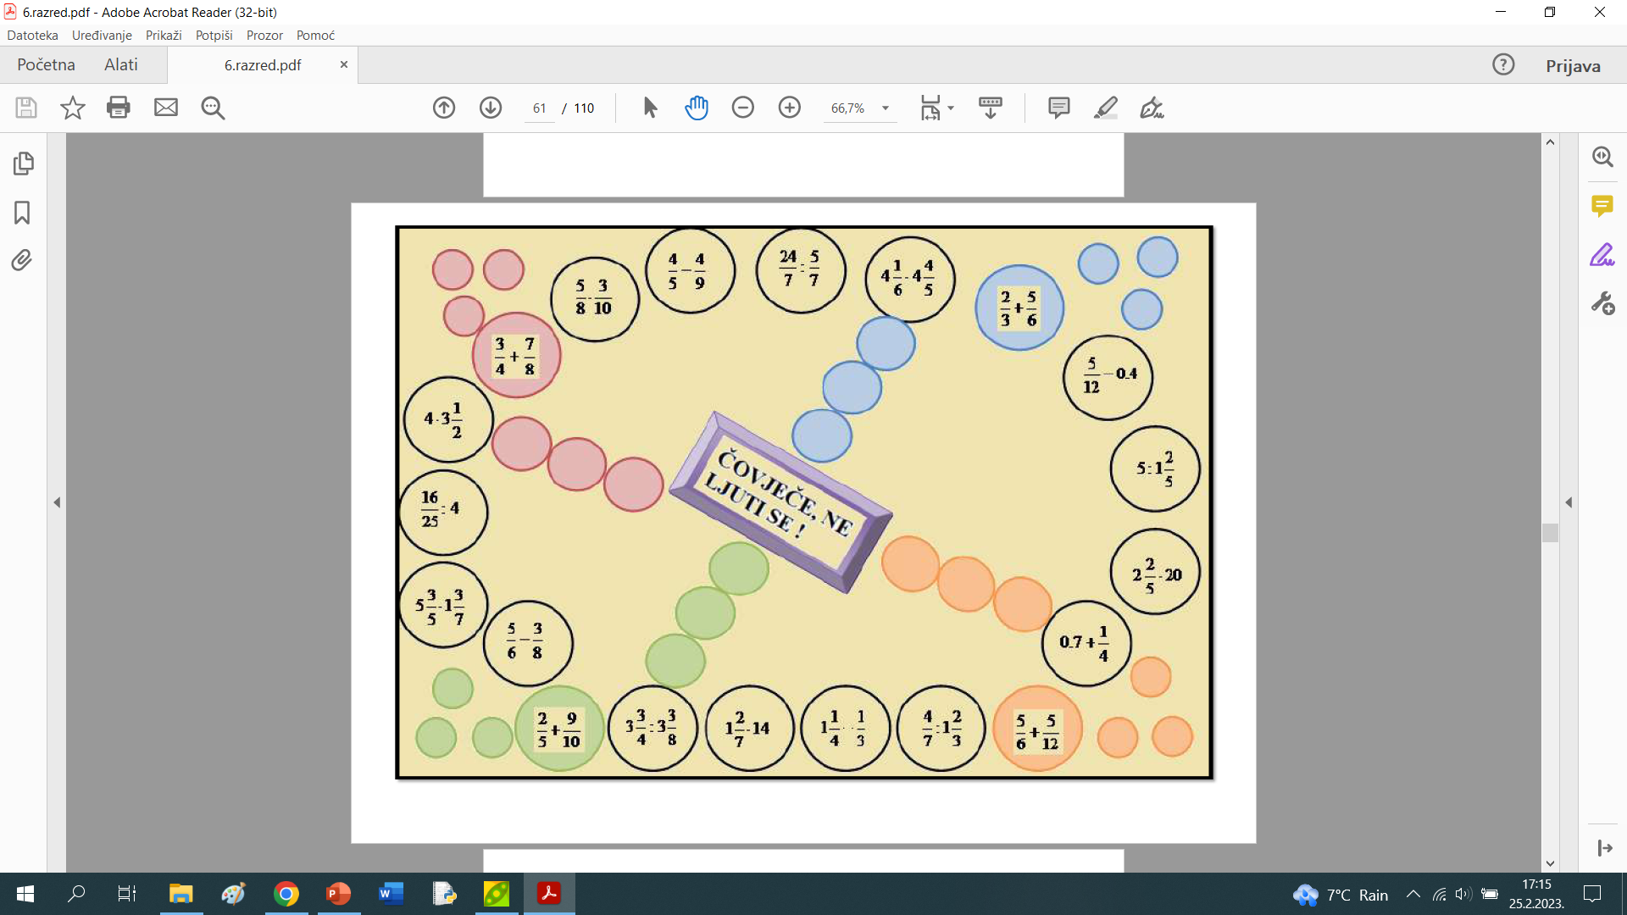

50% of 27

50% of 17

50% of 43

50% of 31

$$9-8.7$$

$$3-2.6$$

$$6-5.1$$

Author: Viktorija Dimec Redecorated and translated: Martina Brkić

$$9.5-3.3$$

$$6.7-4.5$$

$$8.3-5.2$$

$$7+0.1$$

$$6+0.3$$

$$5+0.2$$

$$\frac{3}{7}+\frac{1}{7}$$

$$4+0.5$$

Man,

don't be mad